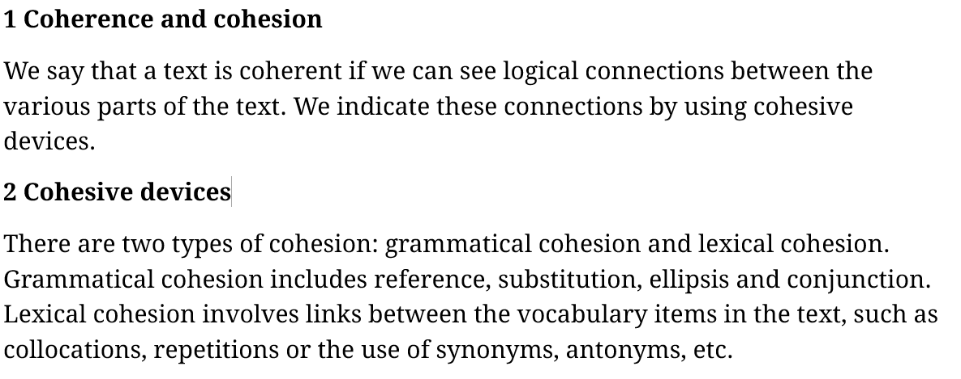  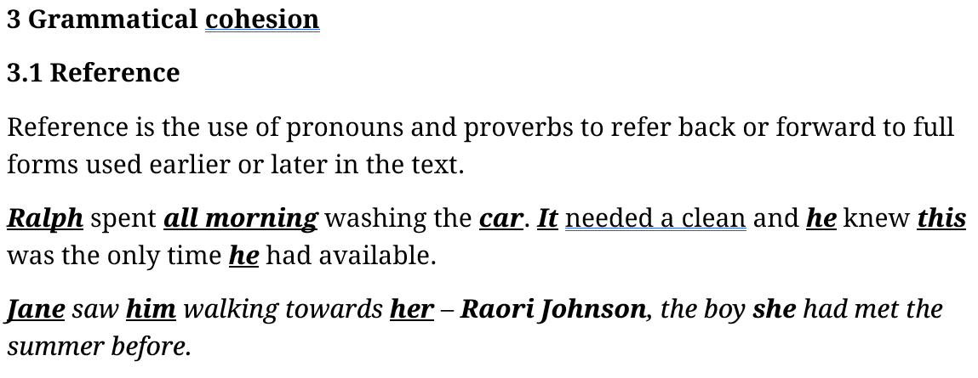 | Task 1: In about 50–100 words, write about one important change you would like to make in your hometown.  Sample response:  I was born in Ho Chi Minh City–one of the largest and most developed cities in Viet Nam. It is always full of people and vehicles, and they produce a lot of emissions. If I have a chance to do one important thing to tackle this issue for my hometown to make it better, I will dedicate a large area of land to building green parks, as these would improve the air quality tremendously.  Task 2: Complete the revised response below. Write ONE suitable word for each gap.  There is one improvement I think I can make to my hometown to make 1______________ a worth-living neighbourhood. If 2______________ could, 3______________ would allocate a large area of land to build green spaces 4______________. 5________ current lack of such a place means it is not possible for children to play safely, and it is also 6______________ (possible) for old people to do morning exercises.  Answer:  There is one improvement I think I can make to my hometown to make it a worth-living neighbourhood. If I could, I would allocate a large area of land to build green spaces there. The/Its current lack of such a place means it is not possible for children to play safely, and it is also impossible for old people to do morning exercises.
 | Task 3: In about 50 – 100 words, write a short description of your ideal home/tools/friend…
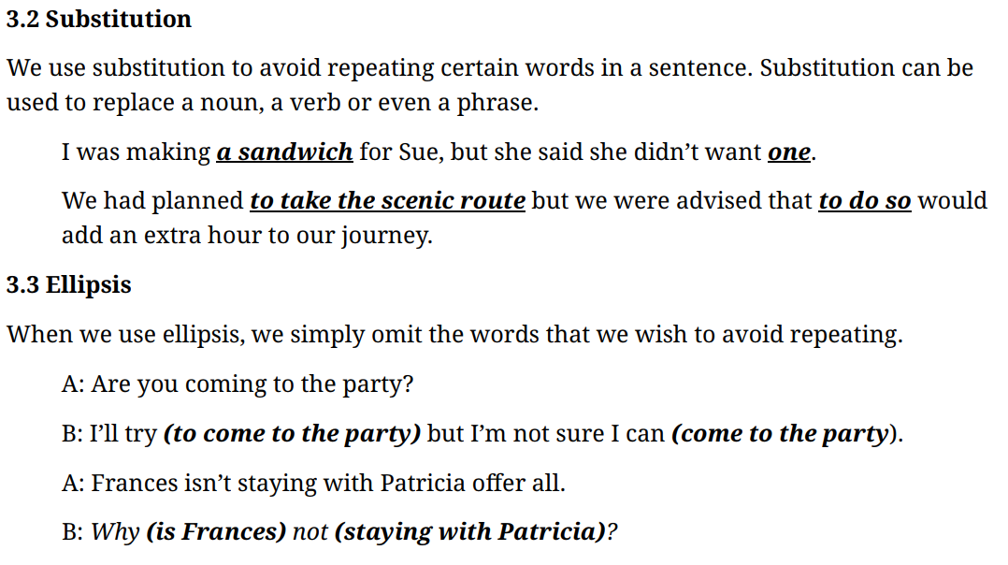 | Task 4: Complete the text below. Write NO MORE THAN TWO WORDS that indicate substitution or ellipsis for each answer.  There are two major solutions to tackle the extinction of land and marine animals. 1_______________ is that governments should curb the amount of plastic waste dumped irresponsibly at sea and on land. 2_______________ timely would help them avoid either mistaking plastic fragments for food and subsequently choke to death or eating contaminated food sources. 3_______________ , their dying out will inevitably come. 4_______________ is to establish more protected habitats and strengthen conservation programmes. By safeguarding breeding grounds and restoring damaged ecosystems, endangered species are given the opportunity to recover and thrive without human disturbance. This measure also enables scientists to monitor wildlife more effectively and intervene when necessary.  Answer  There are two major solutions to tackle the extinction of land and marine animals. One is that governments should curb the amount of plastic waste dumped irresponsibly at sea and on land. Doing so timely would help them avoid either mistaking plastic fragments for food and subsequently choke to death or eating contaminated food sources. If not, their dying out will inevitably come. The other is to establish more protected habitats and strengthen conservation programmes. By safeguarding breeding grounds and restoring damaged ecosystems, endangered species are given the opportunity to recover and thrive without human disturbance. This measure also enables scientists to monitor wildlife more effectively and intervene when necessary.  SUBSTITUTION  are two major solutions - One - The other - This measure  curb the amount of plastic waste dumped irresponsibly - Doing so  establish more protected habitats - By safeguarding breeding grounds  strengthen conservation programmes - restoring damaged ecosystems  ELLIPSIS  avoid either mistaking - or eating - If not → If (we do) not (do so).
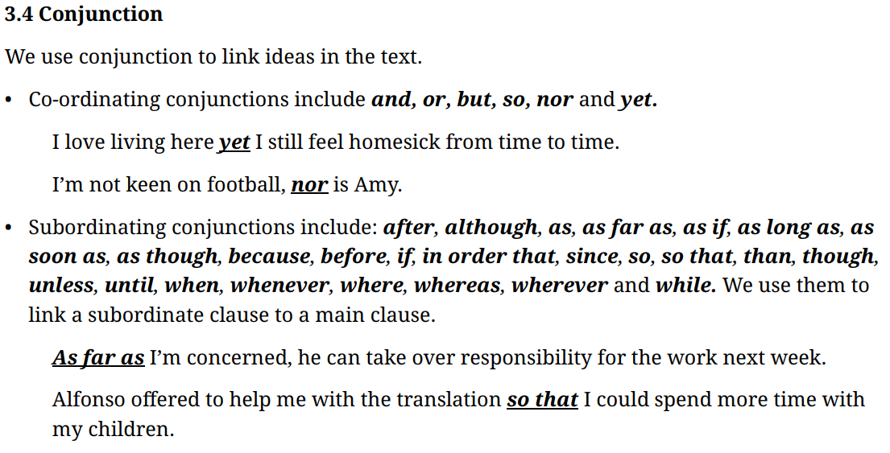  FANBOYS = for, and, nor, but, or, yet, so (nguyên tắc viết của FANBOYS phải có dấu , FANBOYS). Mục đích tạo sự liên kết trong 1 câu.  Nor = cũng không và dùng theo kiểu đảo ngữ.  A: ‘I love you.’ B: ‘So do I’ | Task 5: Fill in the blanks using the appropriate conjunction. Each conjunction can only be used ONCE.  since although but so that and  1. Vietnam is a developing country focusing on agricultural activities, especially on farming and husbandry. In the last decade, the country’s farming technology has witnessed many major innovations, and the same has happened for husbandry techniques.  2. Cattle farming is an important economic sector in Northern Vietnam. It has long been a source of income for many families living in rural areas here. Developed countries around the world have invested greatly in this industry in an attempt to create more sustainable and eco-friendly methods for farmers, but not many has been successfully implemented.  3. Farming is a traditional practice that people around the world have been doing for ages since/because it provides the most substantial source of resource to maintain our live. Although it has already been developed and improved many times throughout the history of civilization, people are still looking for more enhancement methods. For example, in the modern era, husbandry techniques are being equipped with state-of-the-art technology to improve productivity so that we can reduce the workload for the farmers. So is it the case for agricultural activities.  Task 6: Write a short paragraph about farming and husbandry or cattle farming. Try to link your ideas using ‘because’, ‘whereas’, and ‘while’.  Sample response:  Cattle farming supports rural livelihoods ________ it provides milk, meat, and income for many families. Farmers manage grazing and shelter, ________ ranchers may focus on larger herds and open land. Good husbandry matters ________ careful feeding, health checks, and clean water keep animals productive.  Cattle farming supports rural livelihoods because it provides milk, meat, and income for many families. Farmers manage grazing and shelter, whereas ranchers may focus on larger herds and open land. Good husbandry matters while careful feeding, health checks, and clean water keep animals productive.  Task 7: Read 2 opening paragraphs for the task below. Choose the most suitable word/phrase for each blank.  The most important element in a person’s life is their work. Without a satisfying career, life is meaningless. To what extent do you agree or disagree?  Task 8: Produce the opening paragraph for the task below. Use ‘nor’ in your writing.  The most important element in a person’s life is their work. Without a satisfying career, life is meaningless. To what extent do you agree or disagree?  Sample response: Life fulfilment comes from different things, with some believing that the key to it is a satisfying career. ________ I would admit that one’s profession contributes to it, at the same time I would argue it’s not the most important element, ________ is it the only thing that makes life meaningful.  Life fulfilment comes from different things, with some believing that the key to it is a satisfying career. While I would admit that one’s profession contributes to it, at the same time I would argue it’s not the most important element, nor is it the only thing that makes life meaningful.
  1 | Vietnam is a developing country focusing on agricultural activities, especially on farming and husbandry. In the last decade, the country’s farming technology has witnessed many major innovations, ________ the same has happened for husbandry techniques.
  2 | Cattle farming is an important economic sector in Northern Vietnam. It has long been a source of income for many families living in rural areas here. Developed countries around the world have invested greatly in this industry in an attempt to create more sustainable and eco-friendly methods for farmers, ________ not many has been successfully implemented.
  3 | Farming is a traditional practice that people around the world have been doing for ages ________ it provides the most substantial source of resource to maintain our lives. ________ it has already been developed and improved many times throughout the history of civilization, people are still looking for more enhancement methods. For example, in the modern era, husbandry techniques are being equipped with state-of-the-art technology to improve productivity ________ we can reduce the workload for the farmers.
  1 | Many believe that a ________ is a pivotal aspect of a person’s life. If one does not enjoy their work, they might not find life to be meaningful, nor is it worth living for.  a. meaningful life b. good job c. crucial factor d. career opportunity
  2 | Some argue that neither having quality relationships nor financial freedom is ________ to one’s life, but to establish a solid career matters the most.  a. meaningless b. crucial c. worthless d. satisfactory
Task 9:
In about 70 – 100 words, write a short paragraph about traffic congestion. After you have finished, underline the cohesive devices you use and highlight the nouns, verbs they refer back to.
It is believed that traffic congestion is a challenging issue that not only developing countries have to deal with, but so do the more developed ones. Among many reasons leading to this problem, two major factors stand out as the root causes. One is that the availability of public transportation is insufficient, while the need for commuting is ever increasing. If governments invest more in buses and trains, traffic jams would see a major decrease. Doing so would also reduce the amount of emissions. The other is the poor infrastructure condition. This leads to vehicles having to travel at lower speeds, while ones that try not to do so might cause accidents, ultimately leading to the said issue.✔️
Traffic congestion is among pressing issues in Vietnam. There are two main reasons contributing to this problem. One is that the roads here are poorly designed with few lanes and there are not enough highways constructed to accommodate the volume of traffic, especially in metropolises. It is almost impossible to get out of the traffic jams during peak hours, nor is it to find a detour. The other is the people’s negligence of traffic laws. This can be seen in both urban and rural areas within the country. ✔️
It is strongly believed that traffic congestion is one of the most challenging problems that people in Vietnam are facing recently. In such a developing country, this could be considered as an inevitable consequence when infrastructure cannot match the booming population. Although a huge amount of money and effort have been dedicated to tackle it, the problem itself still persists and is impossible to be handled in a short period of time, nor can it be done by establishing a few simple plans. However, there are some rational suggestions that have been made lately to gradually cope with this painful challenge. One is limiting the number of vehicles that can run on the roads at the same time. The other is to raise people’s awareness regarding regulations. ✔️

Sample response: Traffic congestion is most common in major cities. Overcrowding is the major cause of this problem, and it is getting increasingly bad as cities grow in size. Governments around the world have come up with various measures to tackle traffic congestion. While many of them are not so successful, some have produced the desired effects. Learning from unsuccessful attempts, countries will not try to expand roads because to do so will just accommodate more vehicles. Instead, they focus their resources on building a more efficient and extensive public mass rapid transit (MRT). These MRT systems, according to reports, have contributed to easing traffic congestion in some major cities, including Singapore and Bangkok.

After the morning rush hour begins, the highway slows to a crawl, although city planners have tried to widen the lanes. As the cars pile up, the heavy traffic looks as if it is a parking lot, extending as far as the eye can see. Drivers remain stuck as long as the bottleneck ahead persists, but as soon as it clears, a brief flow resumes. Some drivers honk as though noise will magically clear the path, because they are frustrated before their workday has even started. If more commuters carpooled, the gridlock might ease, in order that traffic could flow more freely. Since the city population has grown, delays have increased, and drivers merge aggressively so they can gain a few meters, so that they might arrive on time. The congestion is far worse today than it was a decade ago, though new policies are being considered. Unless drastic measures are taken, the gridlock will not vanish until late in the evening. When the light finally turns green, chaos ensues whenever someone hesitates. We often see backups where the highway narrows, whereas the side streets remain empty. Wherever you drive in the city, resistance awaits, while pedestrians move faster on the sidewalks.

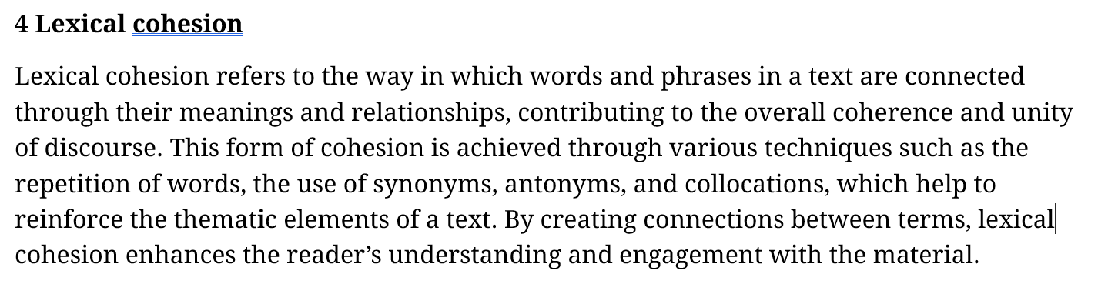  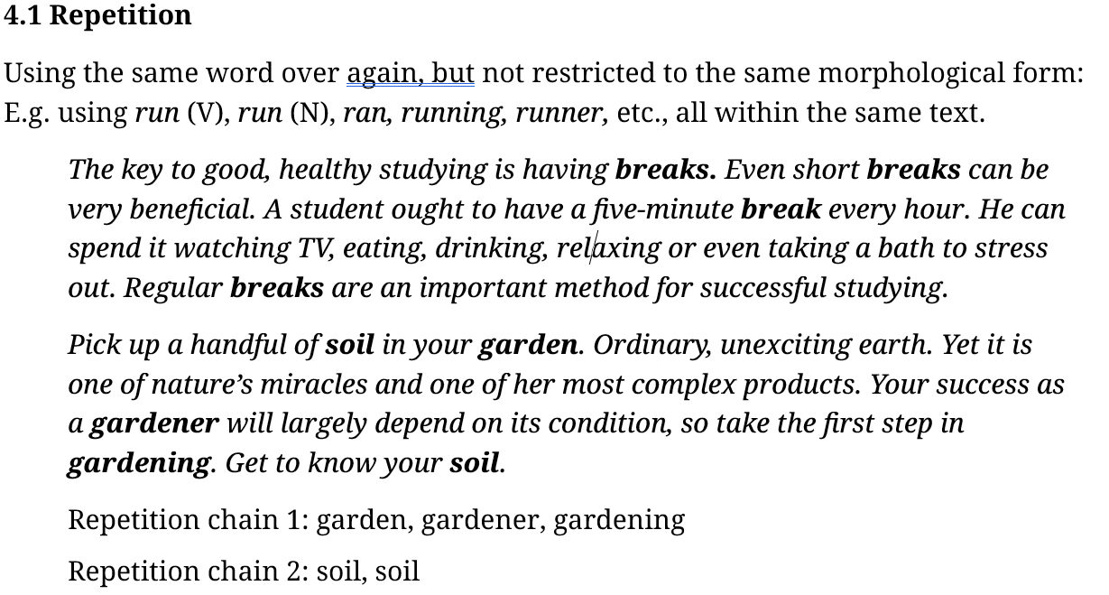  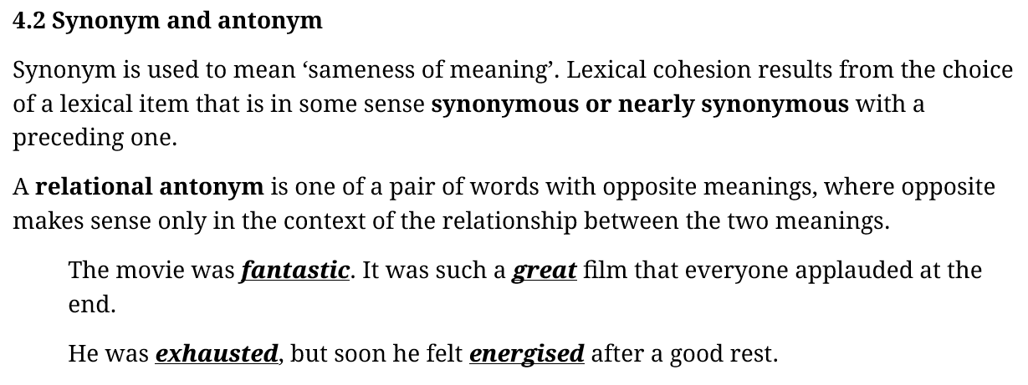 | Paragraph 1:  Ha Noi Marathon is an annual running event that was first started in 2003. Since then, it has attracted runners from all over the country. People take part in this run to promote a healthier lifestyle, as they run for hundreds of miles across the nation.  Paragraph 2:  International Dance League is the first global professional dance competition where dance teams compete against each other like real athletes in sports franchises with contracts and salaries. This competition is organised to elevate dancers to the level of professional athletes. It also aims to ensure career pathways for them to go pro and uses its sponsorship to support the next generation of talented dancers.  Paragraph 3:  The upcoming running event, as I heard on the radio, is going to take place this December, at the end of the month. There are different lengths for every runner. Whether you’re a beginner or an experienced one, all runners start at the café by Long Bridge. The shortest run is 5km while the longest one is 25km. For the $80 registration fee, every runner will receive a designer’s bag containing a T-shirt with the organiser’s logo on.  Task 1: In about 50–100 words, write a paragraph about a running event you have heard about.  Task 2: In about 50–100 words, write about one important change you would like to make in your hometown.  Task 3: Find near-synonyms in the text for the underlined-bolded words.  Over the past thirty years, research in the health arena has attracted psychologists, anthropologists and sociologists. The focus of psychological research in this area is concerned with individual motives, attitudes and beliefs in relation to both health and illness. Anthropological studies, however, are concerned with culture and health care. Such studies concentrate on a conception of disease as a cultural product and on the way social and cultural life in the past affect beliefs about health and illness. In sociological studies, the emphasis is similar but focused more on social relations within a particular social structure with respect to medical care.
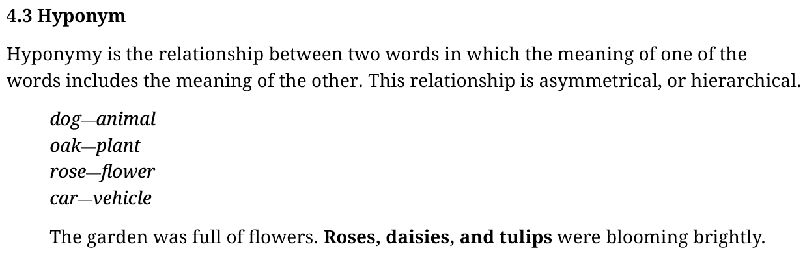 | There are two major solutions to tackle the extinction of land and marine animals. One is that governments should curb the amount of plastic waste dumped irresponsibly at sea and on land. Doing so timely would help them avoid either mistaking plastic fragments for food and subsequently choke to death or eating contaminated food sources. If not, their dying out will inevitably come. The other is to establish more protected habitats and strengthen conservation programmes. By safeguarding breeding grounds and restoring damaged ecosystems, endangered species are given the opportunity to recover and thrive without human disturbance. This measure also enables scientists to monitor wildlife more effectively and intervene when necessary.
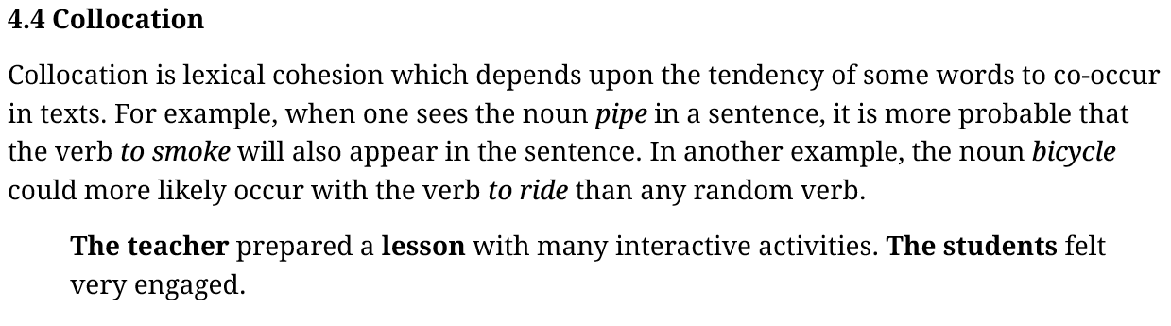 | Identify different lexical cohesion strategies used in the writing below.  Traffic congestion is most common in major cities. Overcrowding is the major cause of this problem, and it is getting increasingly bad as cities grow in size. Governments around the world have come up with various measures to tackle traffic congestion. While many of them are not so successful, some have produced the desired effects. Learning from unsuccessful attempts, countries will not try to expand roads because to do so will just accommodate more vehicles. Instead, they focus their resources on building a more efficient and extensive public mass rapid transit (MRT). These MRT systems, according to reports, have contributed to easing traffic congestion in some major cities, including Singapore and Bangkok.  4.2 (Antonym & Synonym)  4.3 (Hyponym)  4.4 (Collocation)
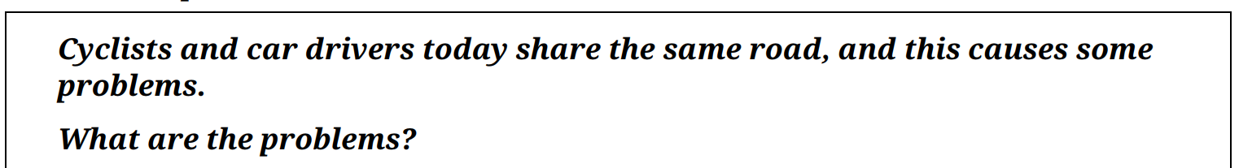 | Task 4: Read the introduction and 2 body paragraphs for the Write Essay question. Fill in the blanks and identify all lexical cohesion features.  In many countries, there is no separate road for car drivers and cyclists. This lack of infrastructure engenders people’s reluctance to use bicycles for short commutes and other resulting traffic problems. The key solution lies in constructing specially designated cycle paths, and other cost-effective measures.  Cyclists are becoming increasingly reluctant to use their bikes for short range travelling when there are no separate lanes for them and car drivers. Two major factors stand out as the reason for such concern. One is that cycling is much slower in comparison to driving. Thus, opting for car drives saves a lot of time. The other is that car drivers are prone to carelessness and distractions while on the road, leading to high rates of accidents. In case of such events, if one is involved in the incident while pedalling, there is less physical protection as compared to sitting in a car.  Many refuse to use bicycles for short commutes as there might be a risk of road accidents. Most roads are mainly designed for cars, leaving little or no space for cyclists. They are forced to ride close to cars, which can increase the likelihood of accidents and discourage commuters from riding on a bike for even short journeys. This tendency can ultimately lead to more reliance on private cars because being in a car appears to be a safer and time-efficient option, but this can further exacerbate the on-going issues of pollution and traffic congestion.  Task 5: In about 50–100 words, write about the potential problems that could happen if cyclists and car drivers share the same road.
  Cyclists are becoming increasingly reluctant to use their _______ for short range travelling when there are no separate lanes for them and _______ drivers. _______ major factors stand out as the reason for such concern. One is that _______ is much slower in comparison to driving. Thus, opting for car drives saves a lot of time. The other is that car drivers are prone to carelessness and distractions while on the road, leading to high rates of _______ . In case of such events, if one is involved in the incident while pedalling, there is less physical _______ as compared to sitting in a car.
  Many refuse to use bicycles for short commutes _______ there might be a risk of road accidents. Most roads are mainly designed for cars, leaving little or no space for cyclists. They are forced to ride close to cars, _______ can increase the likelihood of accidents _______ discourage commuters from riding on a bike for even short journeys. _______ tendency can ultimately lead to more reliance on private cars _______ being in a car appears to be a safer and time-efficient option, _______ this can further exacerbate the on-going issues of pollution and traffic congestion.

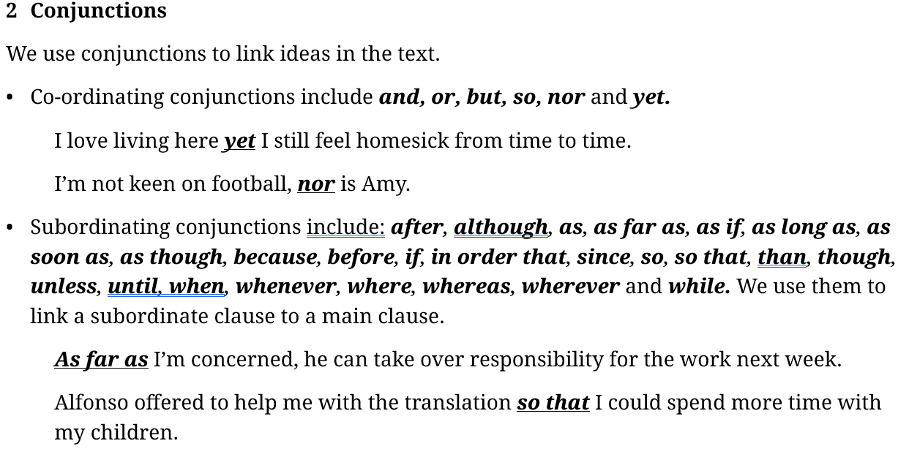
→ Conjunctions are used to connect two parts of the same sentence and will follow only one comma.
3.1 Transitional Words & Phrases  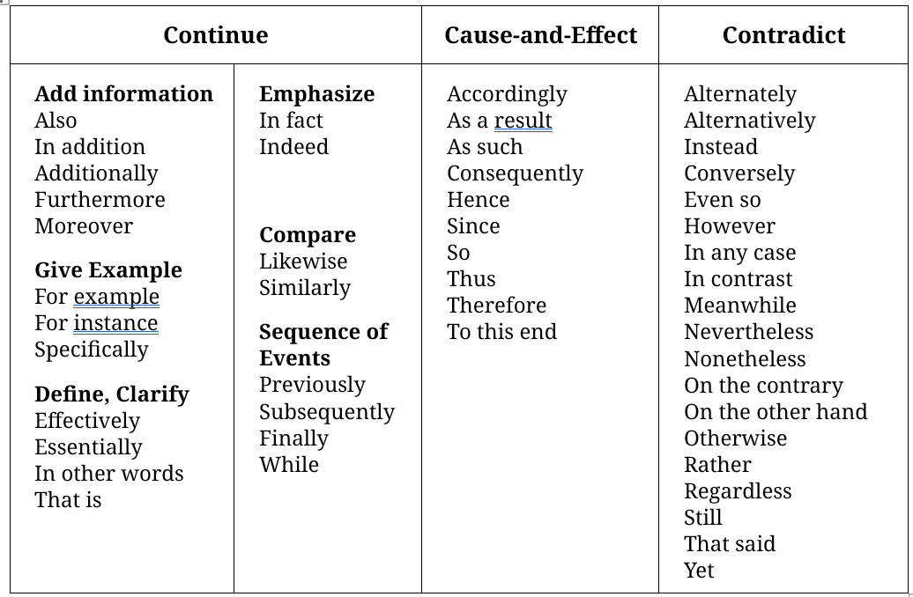  Transitional phrases/words are used to show the relationship between two sentences: the sentence that contains the transition and the previous sentence(s). | Task 1. Fill the gaps with the appropriate transitional words or phrases  - Erenna sirena, a relative of the jellyfish, is one of the rare marine organisms to emit red light. ______________, only a few other deep-sea creatures produce a glow that color.  In fact / Indeed  - The light from most quasars was emitted when the universe was only a fraction of its present age. ______________, quasars offer an important clue to the appearance of the early universe.  Therefore, / Thus  - An increased reliance on computerized systems can leave users vulnerable to cyberattacks. ______________, current defenses are stronger than many people realize.  However, / In contrast  Task 2. Write sentences about the ongoing trend of digitalized reading resources replacing printed books. Use the suggested transitional words/phrases
  In addition
  Thus
  Nonetheless
  Subsequently
3.2 Positions of transitional words  - At the beginning of a sentence  Healthy arctic marine mammals have a thick layer of fat beneath the skin. Tropical marine mammals have very few fat reserves in their bodies. As a result, many of them dwell primarily in the warm waters that surround coral reefs.  - In the middle of a sentence  Healthy arctic marine mammals have a thick layer of fat beneath the skin. Tropical marine mammals, however, have very few fat reserves in their bodies. Many of them dwell primarily in the warm waters that surround coral reefs.  - At the end of a sentence  Healthy arctic marine mammals have a thick layer of fat beneath the skin. Tropical marine mammals have very few fat reserves in their bodies, however. Many of them dwell primarily in the warm waters that surround coral reefs. | What could happen if cyclists and car drivers share the same road?  The first problem concerns people’s poor appetite for cycling. Bicycles are slow while cars are fast; some drivers may sometimes overestimate their driving skills, so they cause collisions on shared roads. Safety concerns would, therefore, discourage cyclists from even a short ride. As fewer people use bikes, more would switch to large cars that occupy space on the road. This preference is certainly the root cause of several other [traffic issues. Roads get congested more frequently; the air gets increasingly filled with exhaust fumes; people’s respiration suffers].  Task 3. Read the passage above and identify grammatical & lexical cohesion features. Follow the guidelines below:  - References: highlight both the references and the referred words (with the same color).  - Repetition: Underline.  - Conjunctions: Bold & Italicize.  - Substitution: Bold.  - Collocation: list out all pairs/groups of collocation  - Cycling: bicycles, cy____,  - Cars: drivers, dr___ sk___, r___  - Roads: collisions, sa__ con___, tr___, con____, ex____ f___  - Hyponym: Place brackets [] on the hyponyms  Task 4. Write a short introduction to this essay topic. Use appropriate conjunctions and transitional words/phrases.  Some people think that it is best to live in a vertical city, where people work and live in tall buildings, while others think a horizontal city is better.  Discuss both views and give your opinion.  1. Life in high-rise cities is considered better for many people, although some enjoy theirs in low-rise ones. While living in upwardly-built areas would be beneficial for overall physical and mental health, settling for outwards homes provide much more personal privacy. I concur that the formerly-mentioned lifestyle is the better choice.  2. While many prefer living and working in high-rise buildings, others opt for low-rise homes and workplaces. Each type of architectural design has its own perks. However, I believe that being able to enjoy open space and a broad skyline is essential for having a quality life.  3. In some countries, major cities are full of high-rise buildings. In others low-rise buildings are the norm, however. I would argue that building upwards rather than outwards is a better choice given the high demands for accommodation in large cities today.
  Life in high-rise cities is considered better for many people, ______ some enjoy theirs in low-rise ones. ______ living in upwardly-built areas would be beneficial for overall physical and mental health, settling for outwards homes provide much more personal privacy. I concur that the formerly-mentioned lifestyle is the better choice.
  ______ many prefer living and working in high-rise buildings, others opt for low-rise homes and workplaces. Each type of architectural design has its own perks. ______, I believe that being able to enjoy open space and a broad skyline is essential for having a quality life.
  In some countries, major cities are full of high-rise buildings. In others, low-rise buildings are the norm, ______. I would argue that building upwards rather than outwards is a better choice given the high demands for accommodation in large cities today.
4 Linking scope  Linking scope refers to the extent to which certain words and/or their positions affect the meaning of a sentence. Linking scope can also be used to explain certain grammatical patterns. | Task 5. What ONE word best fits the following sentences? Explain the meaning sentence by sentence.  1. ___________ John hit Andy in the eye yesterday.  2. John ___________ hit Andy in the eye yesterday.  3. John hit ___________ Andy in the eye yesterday.  4. John hit Andy ___________ in the eye yesterday.  5. John hit Andy in ___________ the eye yesterday.  6. John hit Andy in the ___________ eye yesterday.  7. John hit Andy in the eye ___________ yesterday.  8. John hit Andy in the eye yesterday ___________ .  Answer:  1. Only John hit Andy in the eye yesterday. [nobody else hit Andy]  2. John only hit Andy in the eye yesterday. [John did nothing else to Andy apart from hitting him]  3. John hit only Andy in the eye yesterday. [John hit nobody else in the eye]  4. John hit Andy only in the eye yesterday. [and not outside the eye]  5. John hit Andy in only the eye yesterday. [and not other body parts]  6. John hit Andy in the only eye yesterday. [Andy has only one eye]  7. John hit Andy in the eye only yesterday. [and not some other day]  8. John hit Andy in the eye yesterday only . [he didn’t want to do it any other day]

RFIB 21.
People are generally living longer than previous generations across most parts of the world. Rising life expectancy is a result of advances in medicine as well as improving living standards and healthier lifestyles. But while this should be __________ for social reasons, is it beneficial in economic terms? Does the increase in the older population create an economic burden on society or can older people be mobilized to __________ the productivity of communities in which they work and live? New analysis of international data from 35 countries, published by the International Longevity Centre, provides more evidence in favor of a 'longevity dividend'. The authors found that as life expectancy increases, so __________ “output per hour worked, per worker and per capita”.
People are generally living longer than previous generations across most parts of the world. Rising life expectancy is a result of advances in medicine as well as improving living standards and healthier lifestyles. But while this should be celebrated for social reasons, is it beneficial in economic terms? Does the increase in the older population create an economic burden on society or can older people be mobilized to enhance the productivity of communities in which they work and live? New analysis of international data from 35 countries, published by the International Longevity Centre, provides more evidence in favor of a 'longevity dividend'. The authors found that as life expectancy increases, so does “output per hour worked, per worker and per capita”.

Hyponym:
Living longer = rising life expectancy = increase in the older population

References:
This =
It =

Conjunction
Or = contrastive → create burden >< _______ productivity
So (continuation) = also
Vocab: in favor of → refer to a previously mentioned side/aspect out of 2 or more

